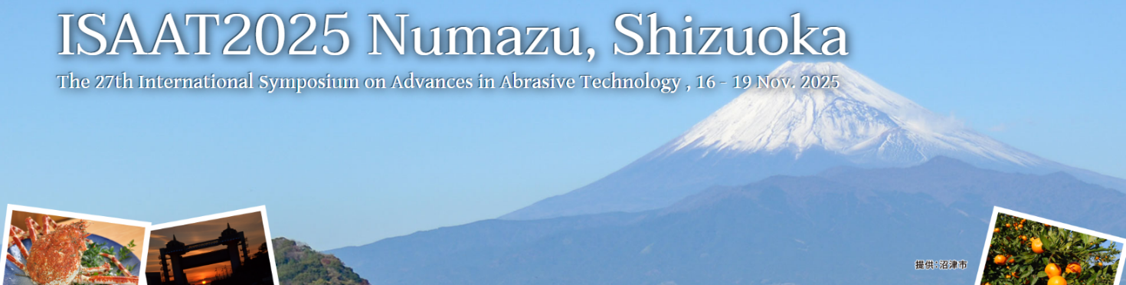

Call for Panel Exhibitors by Research Institutes

[ ISAAT2025 Organizing Committee ]

ISAAT2025 (<https://www.scoop-japan.com/kaigi/isaat2025/index.html>) will have spaces for “Panel Exhibit by Research Institute”. We expect almost 200 participants from many countries. We hope that you will take advantage of this opportunity to appeal your institute's R & D potential directly to many participants from Japan and abroad.

1．Date: Nov. 16(Sun) – 19(Wed), 2025　　*Panel exhibit will be on Nov. 17(Mon)-18(Tue) (set up on Nov. 16(Sun))

2. Site: Plaza Verde (Numazu-city, Shizuoka-Pref., Japan) (<https://www.plazaverde.jp/en/>)

3. Space: A poster panel board will be prepared for each institution.

Panel size: about 2[m] (Width) x 2.1[m] (Height) (A0 size)

4. Application Eligibility: Those who have already registered (or are going to register) for ISAAT2025.

5. Application due: October 15(Wed), 2025

6. Price: JPY 30,000/Panel

*Due to space constraints, there will be no tables set up in front of the panels. Those distributing materials, etc., are asked to come up with their own arrangements.

*Since this is an exhibition using one of the presentation rooms, please use the break times for explanations.

*It is possible to send the panel(s) to the venue in advance, and the organizing committee will set them up.

*The name of research institution (University, laboratory, etc.) will be included in the symposium program.

*After receiving the application form, we will send an invoice from Scoop Japan Co., Ltd., so please make the payment after you receive the documents.

7. How to apply: Please apply and contact by e-mail using the application form below.

Contact person: Ms. Yoko Tanaka, Scoop Japan Inc.

Address: International Zenrin Kaikan 9F, 1-5-5 Shimbashi, Minato-ku, Tokyo 105-0004, Japan

TEL：+81-3-5568-7501 e-mail: isaat2025@scoop-japan.com

|  |  |
| --- | --- |
| Application Form for "Panel Exhibit by Research Institute" at ISAAT2025  　　e-mail: isaat2025@scoop-japan.com | |
| Number of panel(s) | Panel(s) |
| Institute (organization) and contact person | Institute’s name:  Contact person: Department:　　　　　　　　　　　　　　　　　　Name: |
| Contact information | Address:  TEL:  E-mail: |
| Institute’s or Laboratory’s name for symposium program |  |

*We will contact you later for more details.