(2 Blank Lines,12pt)
Size: A4, Both sides margin: 19mm, Top and bottom margin: 22mm
Please REMOVE this textbox and all red-colored text, before submission.

Manuscript Template for ICPE 2020 (Arial 14pt, Line space 16pt)
(1 Blank line, 9pt)
－If there is no subtitle, remove this line with above 9pt blank line (Arial 9pt, Line space 12pt)－
(1 Blank line, 12pt)
Manabu SEIMITSU*, Kazue SEIMITSU** and Jiro KAMBE* (Times 10pt, Line space 15pt)
(2 Blank lines, 12pt)

Abstract: This Ms Word template file is provided to assist authors in preparing their manuscript for ICPE 2020 proceedings. xxxxx xxxxx xxxxx xxxxx xxxxx xxxxx xxxxx xxxxx xxxxx xxxxx xxxxx xxxxx xxxxx xxxxx xxxxx xxxxx xxxxx xxxxx xxxxx xxxxx xxxxx xxxxx xxxxx xxxxx xxxxx xxxxx xxxxx xxxxx xxxxx xxxxx xxxxx xxxxx xxxxx xxxxx xxxxx xxxxx xxxxx xxxxx xxxxx xxxxx xxxxx xxxxx xxxxx xxxxx xxxxx xxxxx xxxxx xxxxx xxxxx xxxxx xxxxx xxxxx xxxxx xxxxx xxxxx xxxxx xxxxx xxxxx xxxxx xxxxx xxxxx xxxxx xxxxx xxxxx xxxxx xxxxx xxxxx xxxxx xxxxx xxxxx xxxxx xxxxx xxxxx xxxxx xxxxx xxxxx xx xx xx xx xx xx. (Times 8.5pt, Line space 12pt, Margin: Both sides 3 Characters)
Key words: electronic manuscript, style sample, writing manual, publication, international conference (Times 8.5pt, Line space 12pt, Margin: Both sides 3 Characters)
(2 Blank lines, 12pt)

1. Introduction (Heading 1: Bold, Arial 8.5pt, Line space 12pt)
ICPE 2020 Proceedings will include 2-page short papers only, including figures, tables and references, written in English. The manuscript must be submitted via the ICPT 2020 website as a portable document format (PDF) file with a maximum size of 2 MB. The proceedings will be distributed as a USB memory to all registered participants of ICPE 2020 at the conference venue.
A main text should be written using two-column format according to this template. All paragraphs should be indented 5 mm. (Times 8.5pt, Line space 12pt.)
(1 Blank line, 12pt)

2. Figures, Tables, Equations, and References
2.1 Figures (Heading 2: Bold, Times 8.5pt, Line space 12pt)
Please ensure that all the text in your figures is large enough to be clearly read. It is highly recommended that you use the figure caption style shown in Fig. 1. Since the proceedings is distributed as only an electric version, full color figures are available. You may set wide figures across both columns.
(1 Blank line, 12pt)
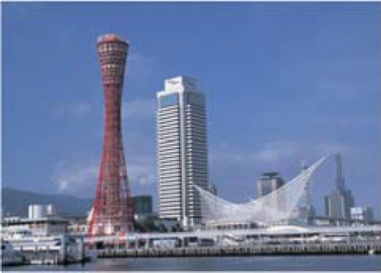
Fig. 1. A caption for a figure. (Times 8pt, Line space 12pt)
(1 Blank line, 12pt)
Figures should be referenced within the text as “Fig. 1.” However, please use “Figure 1” instead of the abbreviation, when the reference to a figure begins a sentence.

*  ** | Graduate School of Engineering, Prec University, 1-1 Umi-machi, Kobe, Hyogo 666-6666, Japan (seimitsu@eng.prec-u.ac.jp)  PrecTech Co., Ltd., 2-1 Yama-machi, Kobe, Hyogo 666-9999, Japan (seimitsu@prectech.co.jp) (Times 7pt, Line space 9pt.)
2.2 Tables
Please place the table number and title above the table, as shown in Table 1. You may set wide tables across both columns.
(1 Blank line, 12pt)
Table 1. A caption for a table. (Times 8pt, Line space 12pt)
City | Kobe | Osaka | Kyoto
Area (km²) | 557 | 225 | 828
Population (Thousands) | 1,522 | 2,742 | 1,466
(1 Blank line, 12pt)
2.3 Equations
An equation should be written with an equation number in parentheses flush with the right margin, as in Eq. (1).
Equations should be referenced within the text as “Eq. (1).” When the reference to an equation begins a sentence, it should be spelled out, e.g., “Equation (1) is …”
$f\left(t\right)=sin⁡(ωt-π/2)$ (1)

2.4 References
The reference list must be formatted as shown below. All the references should be referenced within the text by superscript numbers as ^{1), 2)} or ¹⁻³⁾.

3. Conclusions
If you encounter any problem or have any question concerning the manuscript preparation, please do not hesitate to contact info@icpe2020.jspe.or.jp.

References
- T. S. R. Murthy: Methods for Evaluation of Elliptical Profiles, Int. J. Mach. Tool Des. Res., 25, 4, (1985) 299．
- E. Rabinowicz: Friction and Wear of Materials, John Wiley and Sons, Inc., New York, N. Y., (1965) 52.
- H. Barrell: U. S. Pat., 2720389, (1955).

